$$Regularization Techniques$$

$$Model has three modes$$

$Under fit : High bias-Low variance$

$Normal fit:Low bias-Low variance$

$Overfit :Low bias-High variance$

$$Why Model becomes overfit$$

$Data is not enough$

$Model complexity$

$Linear regression what is meaning of Model complexity$

$Increase the fetaures or columns$

$Logistic regression what is meaning of Model complex$

$Increase the fetaures or columns$

$KNN$

$k=1 (choose the neighbours)$

$DT$

$Depth of the tress is the model complexity$

$$Data is not enough:$$

$$you need to add the data$$

**Google**

**Problem statement:**

**MARKER ===== place is marker is wrong on google maps**

**LOCATION ==== marker is good place is wrong**

**Primary data**

**Those who are using data is called secondary data**

**Churn model**

1. **Sampling techniques**

**Age gender income**

**30 M 50k**

**31 M 50K**

**32 M 49,999**

**Images**

**Data augmentation**



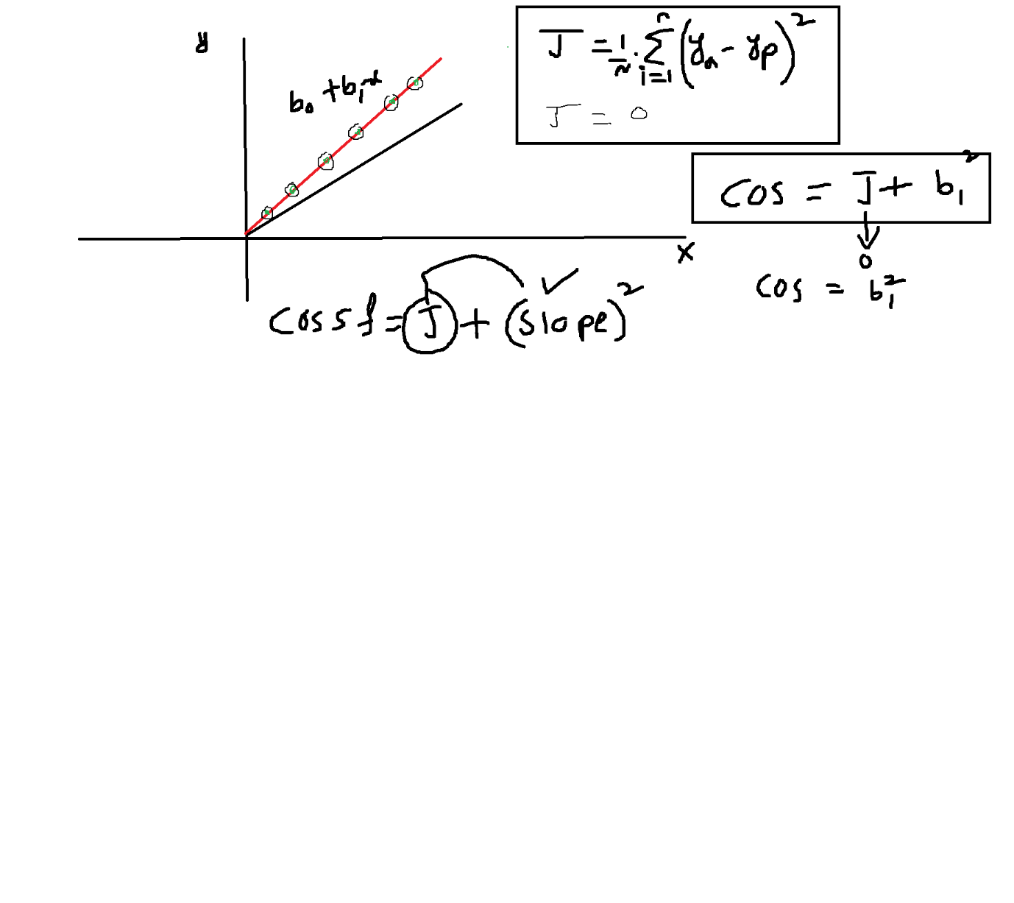

|  |  |  |  |  |
| --- | --- | --- | --- | --- |
| (Ridge and Lasso) | Depth of the tree (DT) | K (KNN) | Features (Regression) | Fitting |
| Max | Low | Max | Low | Underfit |
| 0 | High | 1 | High | Overfit |
| Optimal | Optimal | Optimal | Optimal | Normal |

OLS to find the coefficients

Im not checking anything

**In ols method what we are checking**

$$Lasso Regression:Power=1$$

$$cost function=\frac{1}{n}*\sum_{i}^{n}{{\left(y_{a}-y_{p}\right)}^{2}}+ λ*\sum_{i}^{n}{|b_{i}|}$$

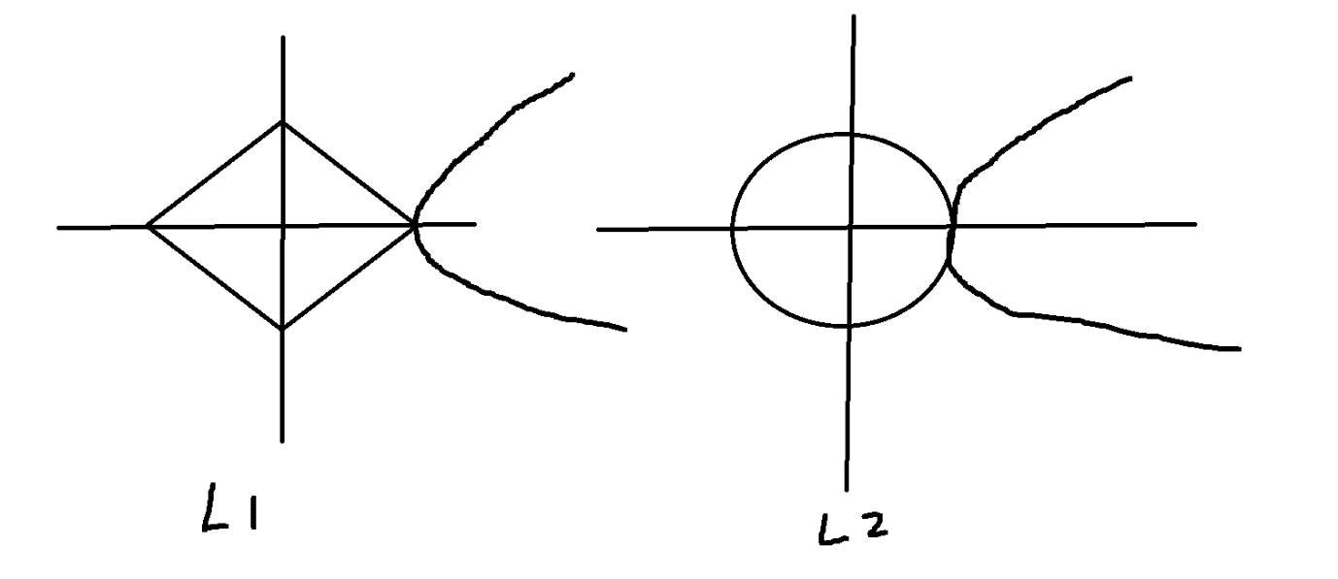

$$Lasso L1 is used as Feature selection$$

$$It will used to select only particular columns$$

$$Graphical represntation of lasso regression shows les area connected with$$

$$Cost function that is the indication we can use less features$$

$$Ridge regression is select all the features and avoid the overfitting$$

$$Graphical represntation of ridge regression shows as much area connected with$$

$$Cost function that is the indication we can use all the features$$

